**Pre-requisite:**

Maven : Any version (apache-maven-3.6.3 used)

Java : Any version (jdk-11.0.6 used)

Browser : Chrome

Chrome Version : 81

ChromeDriver Version : 81

Frameworks : Selenium, TestNG, RestAssured

Language : Java

**Instructions:**

1. Clone the project to your local
2. Open the project as Existing Maven project in your eclipse
3. Open the testdata excel,

* provide Run Flag under RunManager sheet
* provide Test data for test cases under TestData sheet

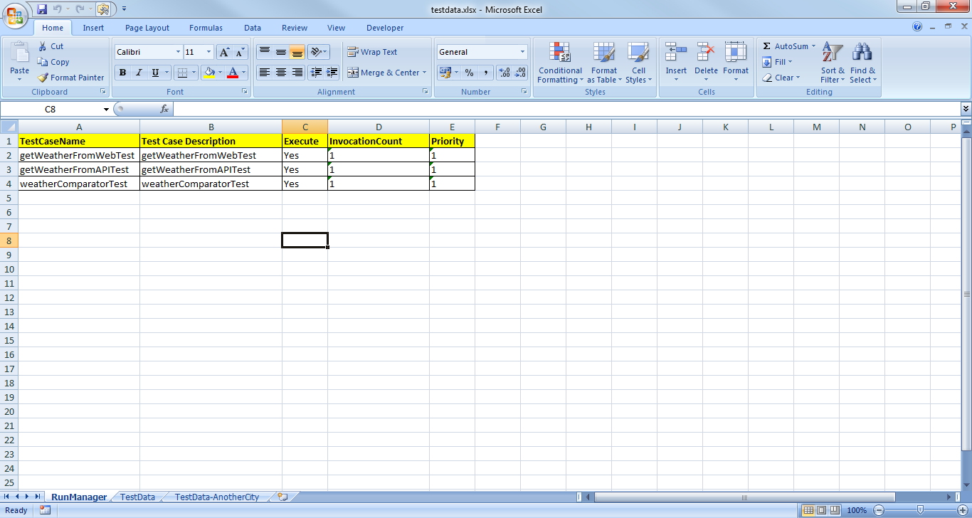

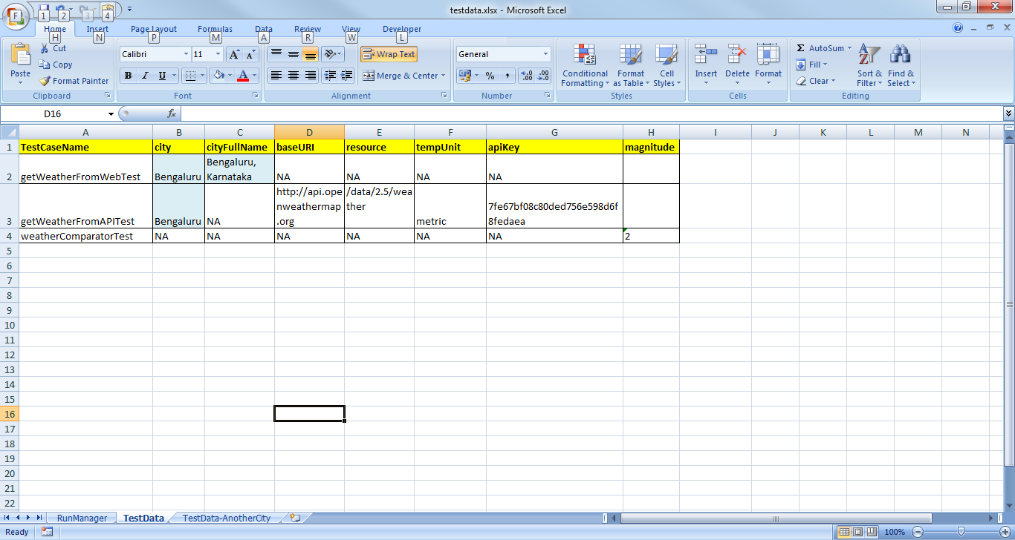

**Note:**

* Test cases having Yes under Run Flag will run. Here all test cases are independent but temperature data is passed between test cases. So I have set Run Flag for all test

cases to Yes

* I have run the Test for Bengaluru City and if you want to run for a different city like Chennai, then u change the data highlighted in blue or take the data present under **TestData-AnotherCity** sheet
* Reports with Screenshots for both Chennai and Bengaluru are under ExtentReports folder inside the project folder
* Not only Bengaluru and Chennai, You can compare temperature of any city by changing values in the testdata excel

1. Open testng.xml and run as TestNG Suite

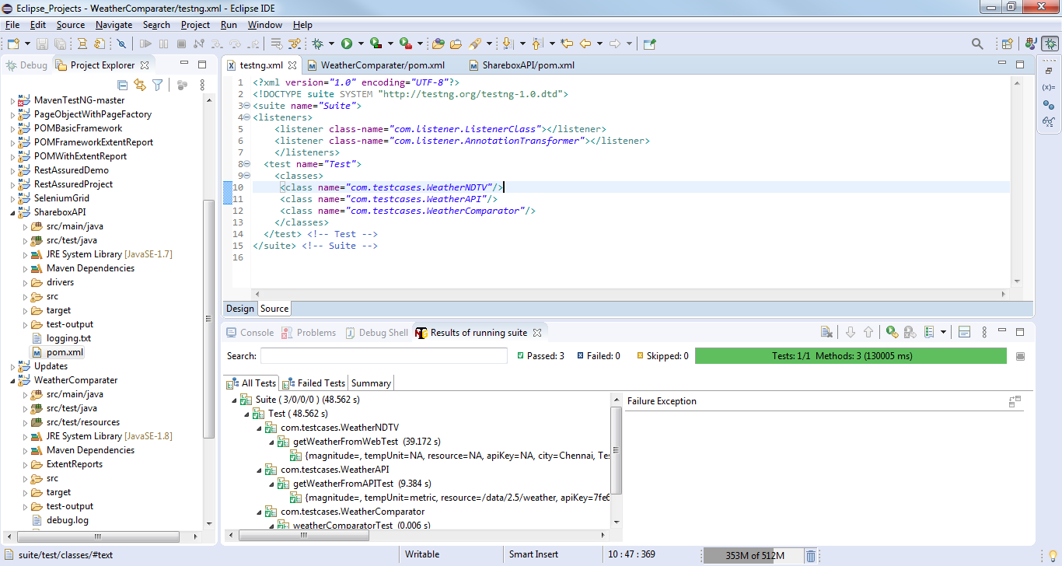

1. Reports will be generated after run under ExtentReports folder inside project folder
2. You can also run through Maven by opening the project folder and go to CMD and give command

* mvn clean test